# **Reference guide: Data cleaning in Python**

This reference guide contains common functions and methods that data professionals use to clean data. The reference guide contains three different tables of useful tools, each grouped by cleaning category: missing data, outliers, and label encoding.

## **Missing data**

The following pandas functions and methods are helpful when dealing with missing data.

### [**df.info()**](https://pandas.pydata.org/docs/reference/api/pandas.DataFrame.info.html#pandas.DataFrame.info)

* **Description:**  A DataFrame method that returns a concise summary of the dataframe, including a ‘non-null count,’ which helps you know the number of missing values

**Example input:**

print(df)

print()

df.info()

**Example output:**

planet radius_km moons

0 Mercury 2440 0

1 Venus 6052 0

2 Earth 6371 1

3 Mars 3390 2

4 Jupiter 69911 80

5 Saturn 58232 83

6 Uranus 25362 27

7 Neptune 24622 14

<class 'pandas.core.frame.DataFrame'>

RangeIndex: 8 entries, 0 to 7

Data columns (total 3 columns):

planet 8 non-null object

radius_km 8 non-null int64

moons 8 non-null int64

dtypes: int64(2), object(1)

memory usage: 272.0+ bytes

### [**df.isna()**](https://pandas.pydata.org/docs/reference/api/pandas.isna.html) **/ isnull()**

* **Description:** A pandas function that returns a same-sized Boolean array indicating whether each value is null (you can also use pd.isnull() as an alias). Note that this function also exists as a DataFrame method.

**Example input:**

print(df)

print('\n After pd.isnull(): \n')

pd.isnull(df)

**Example output:**

Planet radius_km moons

0 Mercury 2440 NaN

1 Venus 6052 NaN

2 Earth 6371 1.0

3 Mars 3390 NaN

4 Jupiter 69911 80.0

5 Saturn 58232 83.0

6 Uranus 25362 27.0

7 Neptune 24622 14.0

After pd.isnull():

Planet radius_km moons

0 False False True

1 False False True

2 False False False

3 False False True

4 False False False

5 False False False

6 False False False

7 False False False

### [**pd.notna()**](https://pandas.pydata.org/docs/reference/api/pandas.notna.html) **/ notnull()**

* **Description:** A pandas function that returns a same-sized Boolean array indicating whether each value is NOT null (you can also use pd.notnull() as an alias). Note that this function also exists as a DataFrame method.

**Example input:**

print(df)

print('\n After notnull(): \n')

pd.notnull(df)

**Example output:**

Planet radius_km moons

0 Mercury 2440 NaN

1 Venus 6052 NaN

2 Earth 6371 1.0

3 Mars 3390 NaN

4 Jupiter 69911 80.0

5 Saturn 58232 83.0

6 Uranus 25362 27.0

7 Neptune 24622 14.0

After notnull():

Planet radius_km moons

0 True True False

1 True True False

2 True True True

3 True True False

4 True True True

5 True True True

6 True True True

7 True True True

### [**df.fillna()**](https://pandas.pydata.org/docs/reference/api/pandas.DataFrame.fillna.html)

* **Description:** A DataFrame method that fills in missing values using specified method

**Example input:**

print(df)

print('\n After fillna(): \n')

df.fillna(2)

**Example output:**

animal class color legs

0 cardinal Aves red NaN

1 gecko Reptilia green 4.0

2 raven Aves black NaN

After fillna():

animal class color legs

0 cardinal Aves red 2.0

1 gecko Reptilia green 4.0

2 raven Aves black 2.0

The following image shows a value of 2.3 replacing a NaN in a data cell.



### [**df.replace()**](https://pandas.pydata.org/docs/reference/api/pandas.DataFrame.replace.html)

* **Description:** A DataFrame method that replaces specified values with other specified values. Can also be applied to pandas Series.

**Example input:**

print(df)

print('\n After replace(): \n')

df.replace('Aves', 'bird')

**Example output:**

animal class color legs

0 cardinal Aves red 2

1 gecko Reptilia green 4

2 raven Aves black 2

After replace():

animal class color legs

0 cardinal bird red 2

1 gecko Reptilia green 4

2 raven bird black 2

The following image shows that four 2s in cells are replacing 0s.

~~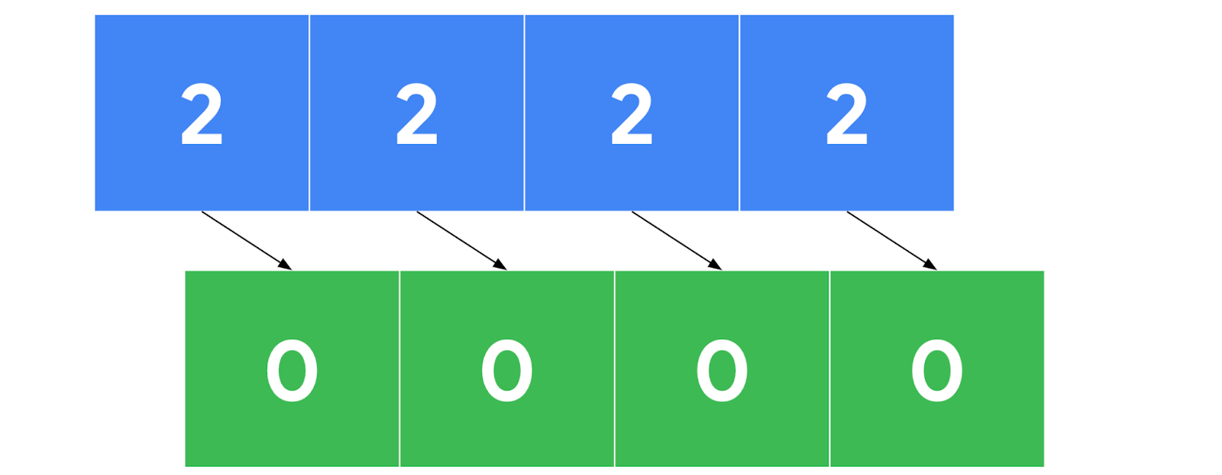~~

### [**df.dropna()**](https://pandas.pydata.org/docs/reference/api/pandas.DataFrame.dropna.html)

* **Description:** A DataFrame method that removes rows or columns that contain missing values, depending on the axis you specify.

**Example input:**

print('Original df: \n \n', df)

print('\n After dropna(axis=0): \n')

print(df.dropna(axis=0))

print('\n After dropna(axis=1): \n')

print(df.dropna(axis=1))

**Example output:**

Original df:

animal class color legs

0 NaN Aves red 2

1 gecko Reptilia green 4

2 raven Aves NaN 2

After dropna(axis=0):

animal class color legs

1 gecko Reptilia green 4

After dropna(axis=1):

class legs

0 Aves 2

1 Reptilia 4

2 Aves 2

The following image shows a sequence of numbers with missing value data cells being removed.

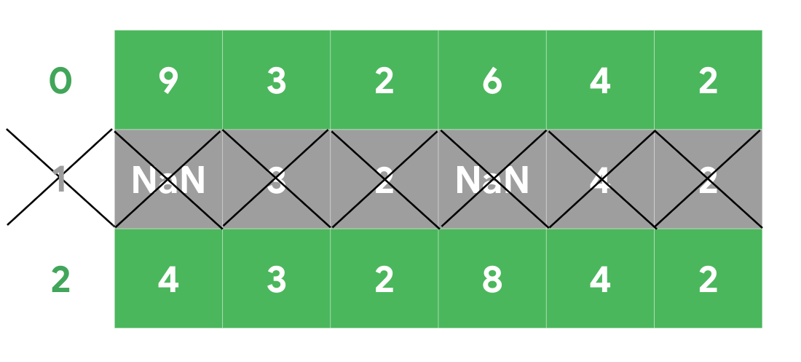

## **Outliers**

The following tools are helpful when dealing with outliers in a dataset.

### [**df.describe()**](https://pandas.pydata.org/docs/reference/api/pandas.DataFrame.describe.html)

* **Description:** A DataFrame method that returns general statistics about the dataframe which can help determine outliers

**Example input:**

print(df)

print()

df.describe()

**Example output:**

planet radius_km moons

0 Mercury 2440 0

1 Venus 6052 0

2 Earth 6371 1

3 Mars 3390 2

4 Jupiter 69911 80

5 Saturn 58232 83

6 Uranus 25362 27

7 Neptune 24622 14

radius_km moons

count 8.000000 8.00000

mean 24547.500000 25.87500

std 26191.633528 35.58265

min 2440.000000 0.00000

25% 5386.500000 0.75000

50% 15496.500000 8.00000

75% 33579.500000 40.25000

max 69911.000000 83.00000

### [**sns.boxplot()**](https://seaborn.pydata.org/generated/seaborn.boxplot.html)

* **Description:** A seaborn function that generates a box plot. Data points beyond 1.5x the interquartile range are considered outliers.

**Example:**

The following image shows an example graph of a box plot with min, max, lower and upper quartiles, and the median labeled.

## An example graph of a box plot with min, max, lower and upper quartiles, and the median labeled

## 

## **Label encoding**

The following tools are helpful when performing label encoding.

### [**df.astype()**](https://pandas.pydata.org/docs/reference/api/pandas.DataFrame.astype.html)

* **Description:** A DataFrame method that allows you to encode its data as a specified dtype. Note that this method can also be used on Series objects.

**Example input:**print(df)

print('\n Original dtypes of df: \n')

print(df.dtypes)

print('\n dtypes after casting \'class\' column as categorical: \n')

df['class'] = df['class'].astype('category')

print(df.dtypes)

**Example output:**

animal class color legs

0 cardinal Aves red 2

1 gecko Reptilia green 4

2 raven Aves black 2

Original dtypes of df:

animal object

class object

color object

legs int64

dtype: object

dtypes after casting 'class' column as categorical:

animal object

class category

color object

legs int64

dtype: object

### [**Series.cat.codes**](https://pandas.pydata.org/docs/reference/api/pandas.Series.cat.codes.html)

* **Description:** A Series attribute that returns the numeric category codes of the series

**Example input:**

# Cast 'class' column as categorical

df['class'] = df['class'].astype('category')

print('\n \'class\' column: \n')

print(df['class'])

print('\n Category codes of \'class\' column: \n')

df['class'].cat.codes

**Example output:**

'class' column:

0 Aves

1 Reptilia

2 Aves

Name: class, dtype: category

Categories (2, object): [Aves, Reptilia]

Category codes of 'class' column:

0 0

1 1

2 0

dtype: int8

### [**get_dummies()**](https://pandas.pydata.org/docs/reference/api/pandas.get_dummies.html)

* **Description:** Converts categorical values into new binary columns—one for each different category

**Example:**

The following image shows a rain column with values of mild, scattered, heavy, and severe is replaced with four new binary columns—one for each category.

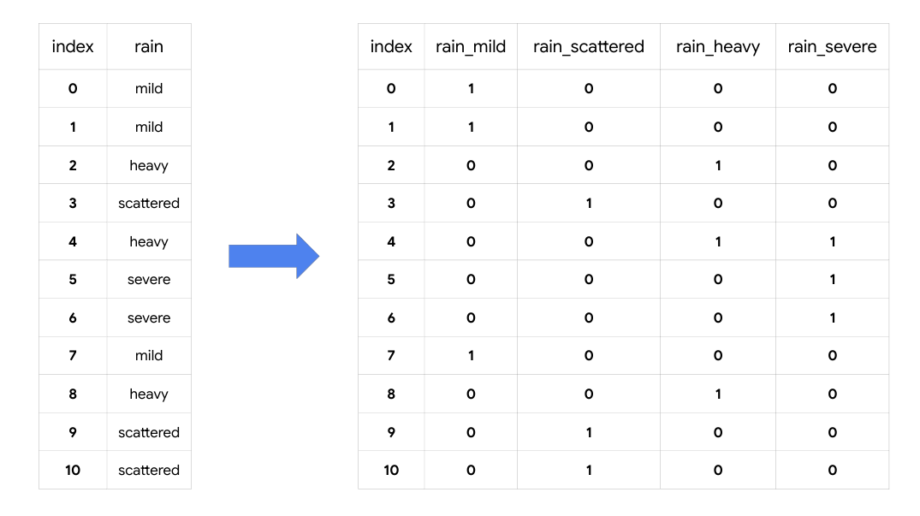

### [**LabelEncoder()**](https://scikit-learn.org/stable/modules/generated/sklearn.preprocessing.LabelEncoder.html)

* **Description:** A transformer from scikit-learn.preprocessing that encodes specified categories or labels with numeric codes. Note that when building predictive models it should only be used on target variables (i.e., *y* data).

**Example:**

**It can be used to normalize labels:**

from sklearn.preprocessing import LabelEncoder

# Instantiate LabelEncoder()

encoder = LabelEncoder()

data = [1, 2, 2, 6]

# Fit to the data

encoder.fit(data)

# Transform the data

transformed = encoder.transform(data)

# Reverse the transformation

inverse = encoder.inverse_transform(transformed)

print('Data =', data)

print('\n Classes: \n', encoder.classes_)

print('\n Encoded (normalized) classes: \n', transformed)

print('\n Reverse from encoded classes to original: \n', inverse)

**Output:**

Data = [1, 2, 2, 6]

Classes:

[1 2 6]

Encoded (normalized) classes:

[0 1 1 2]

Reverse from encoded classes to original:

[1 2 2 6]

**It can be used to convert categorical labels into numeric:**

from sklearn.preprocessing import LabelEncoder

# Instantiate LabelEncoder()

encoder = LabelEncoder()

data = ['paris', 'paris', 'tokyo', 'amsterdam']

# Fit to the data

encoder.fit(data)

# Transform the data

transformed = encoder.transform(data)

# New data

new_data = [0, 2, 1, 1, 2]

# Get classes of new data

inverse = encoder.inverse_transform(new_data)

print('Data =', data)

print('\n Classes: \n', list(encoder.classes_))

print('\n Encoded classes: \n', transformed)

print('\n New data =', new_data)

print('\n Convert new_data to original classes: \n', list(inverse))

**Output:**

Data = ['paris', 'paris', 'tokyo', 'amsterdam']

Classes:

['amsterdam', 'paris', 'tokyo']

Encoded classes:

[1 1 2 0]

New data = [0, 2, 1, 1, 2]

Convert new_data to original classes:

['amsterdam', 'tokyo', 'paris', 'paris', 'tokyo']

## Key takeaways

There are many tools that data professionals can use to perform data cleaning on a wide range of data. The information you learn from missing data, outliers, and transforming categorical to numeric data will help you prepare datasets for further analysis throughout your career.